**Inventory & Order Management System**



Session: 2025 – 2029

**Submitted by:**

Mirza Talal Ahmed 2025(S)-CS-67

**Supervised by:**

Mr. Laeeq Khan Niazi

Department of Computer Science

**University of Engineering and Technology**

**Lahore Pakistan**

**Table of Contents**

**📌 Short Description of the Project**

The **Inventory & Order Management System** is a desktop-based application developed to streamline inventory tracking, order processing, and stock management. It allows businesses to manage items, monitor stock levels, handle customer orders, and keep a basic history of orders. The project was developed using C++.

**👤 Users of the Application**

* **Admin/Manager**:
  + Add, update, or delete inventory items.
  + View a history of all the orders by various customers.
  + View and manage Stock.
* **Customers:** 
  + View items and the details in the inventory.
  + Buy items
  + View a history of their own orders only.

**✅ Functional Requirements**

1. Add new inventory items.
2. Update or delete existing items.
3. View all inventory items.
4. Place new orders.
5. View history of all orders.
6. View history of orders by a specific person.
7. Check stock availability before placing orders.
8. Sorting items based on price.
9. Accounts based login/sign up.
10. Generate user friendly error messages.

🧩 **Wireframes**

* **Landing Page:**

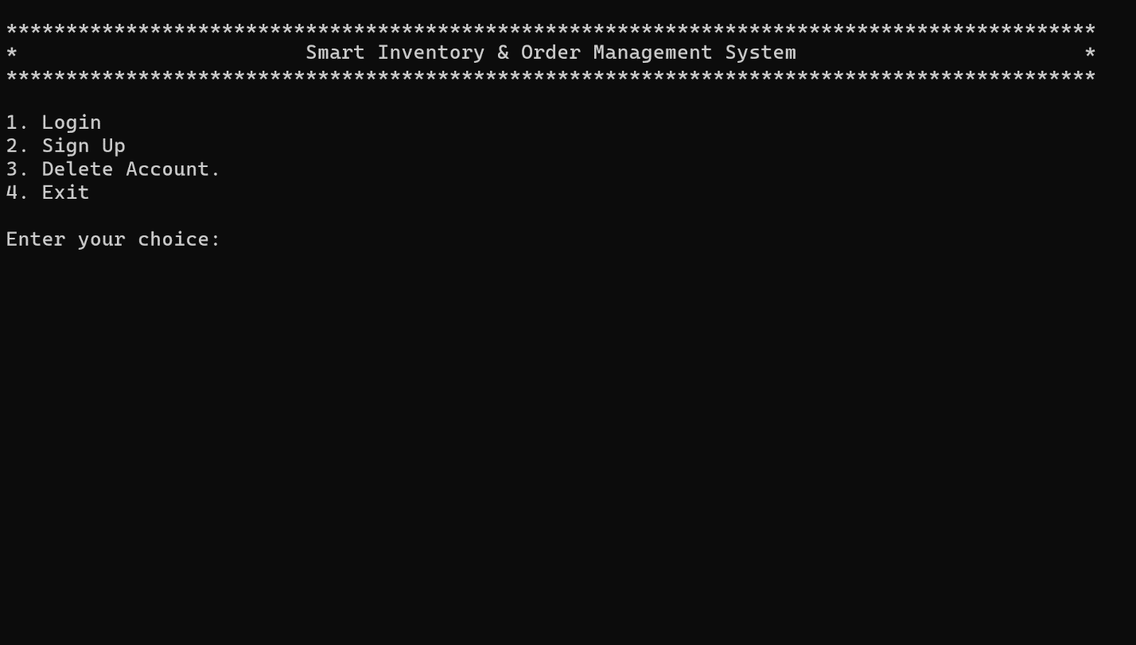

* **Sign Up Menu:**

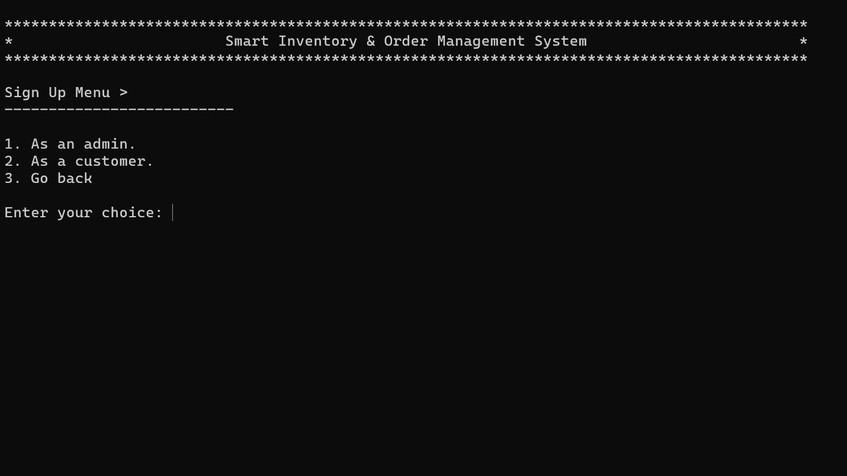

* **Admin Sign Up:**

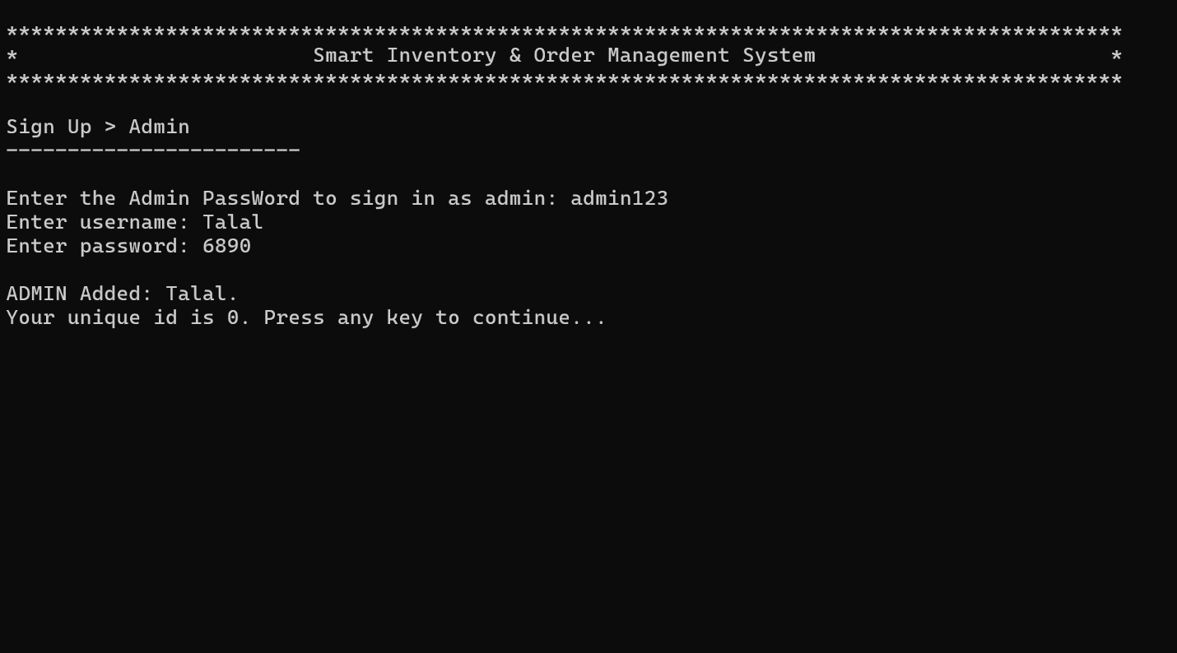

* **Customer Sign Up:**

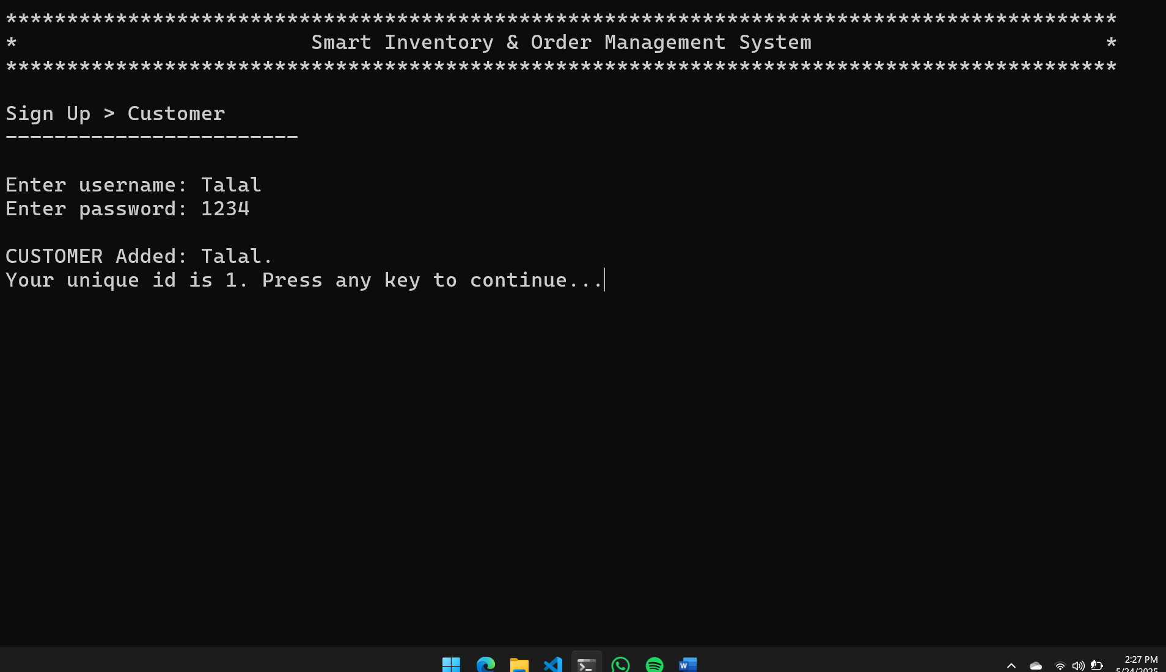

* **Admin Menu:**

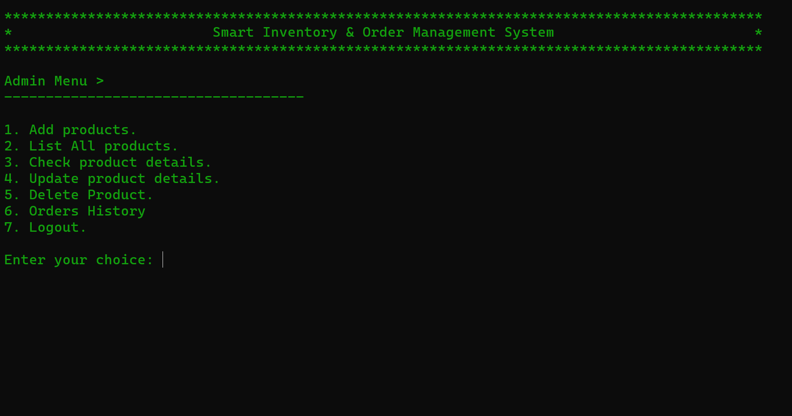

* **Admin Menu > Add Product:**

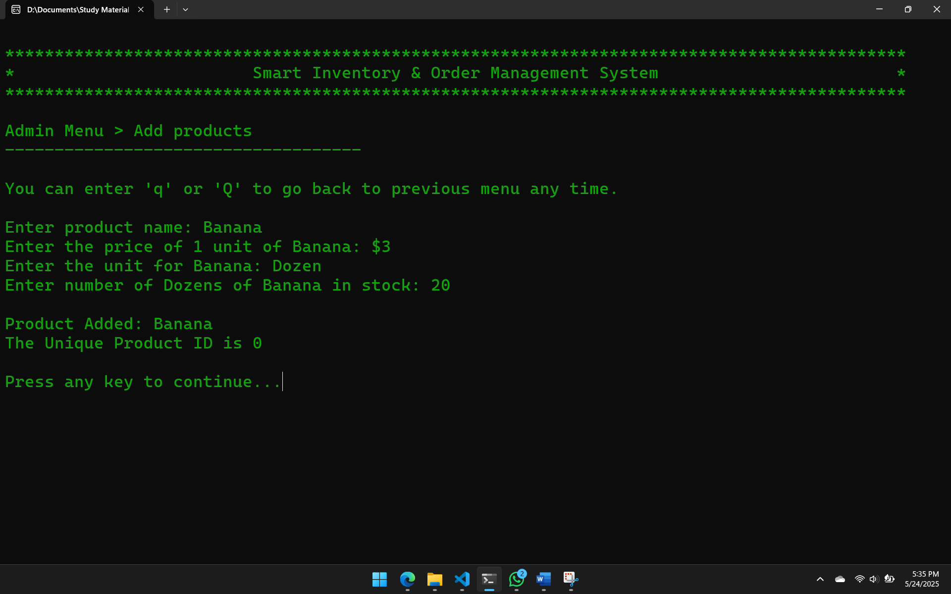

* **Admin Menu > List Products:**

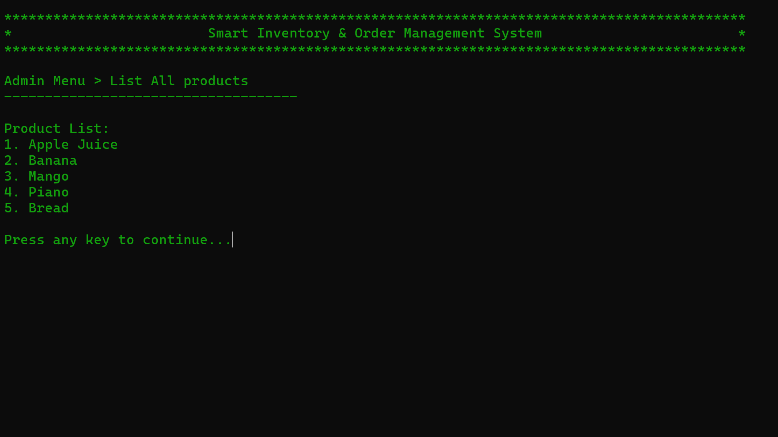

* **Admin Menu > Product Details:**

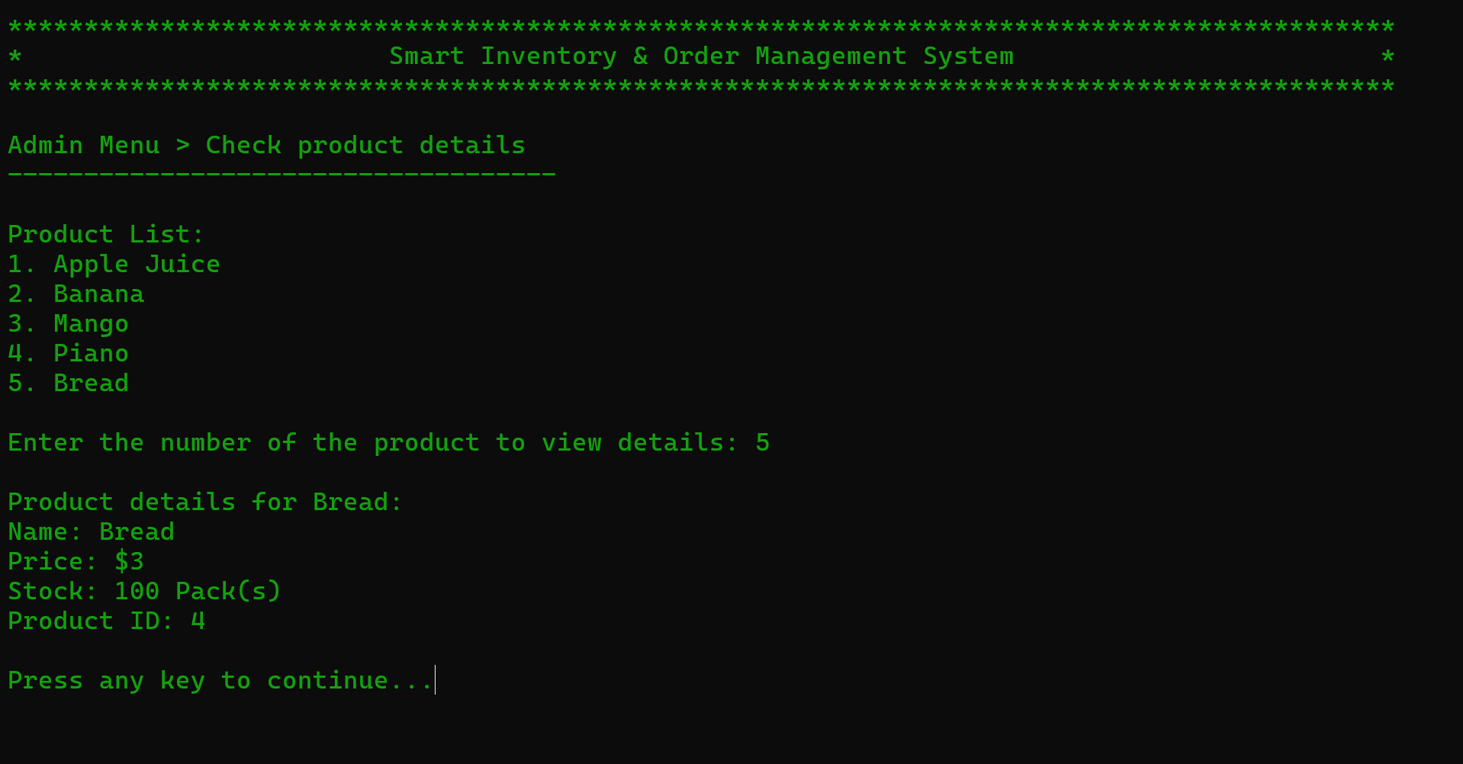

* **Admin Menu > Update Product Details:**

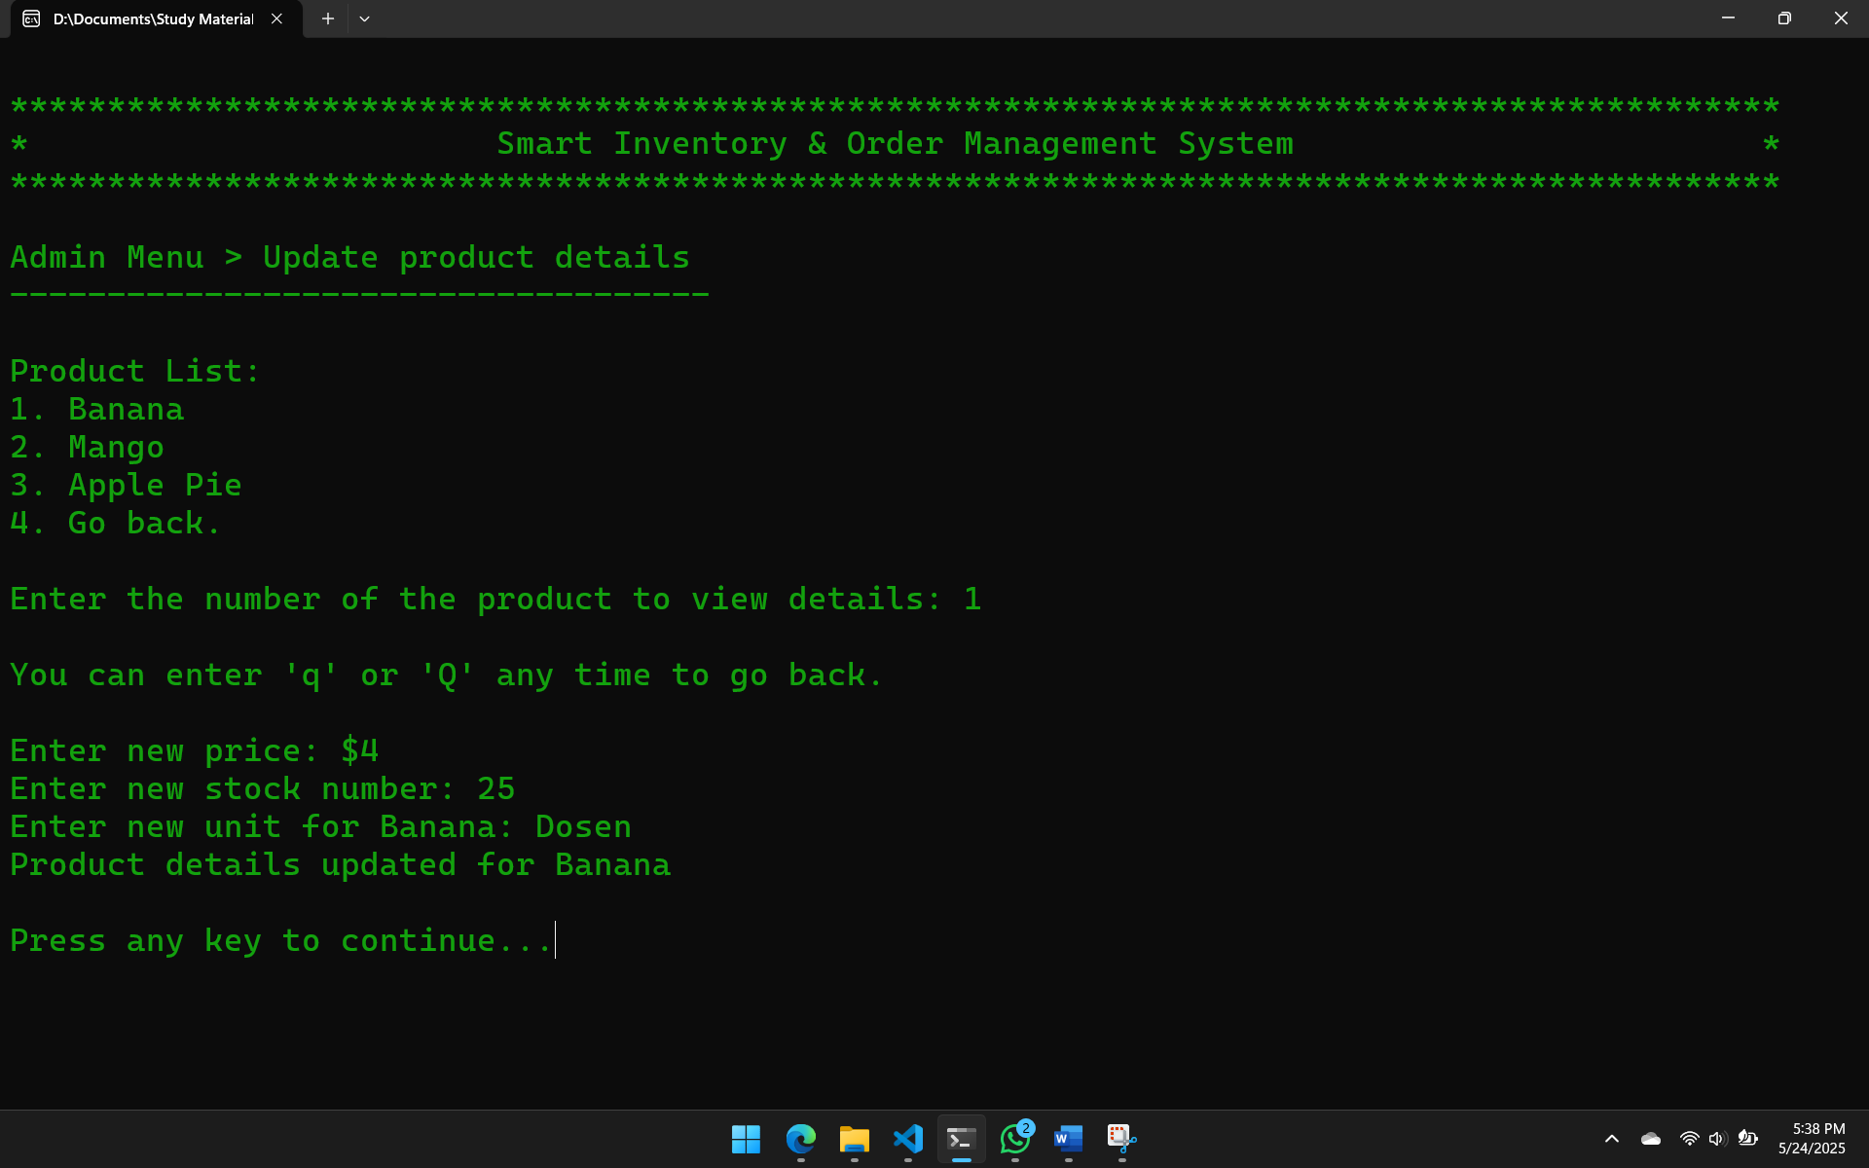

* **Admin Menu > Delete Products:**

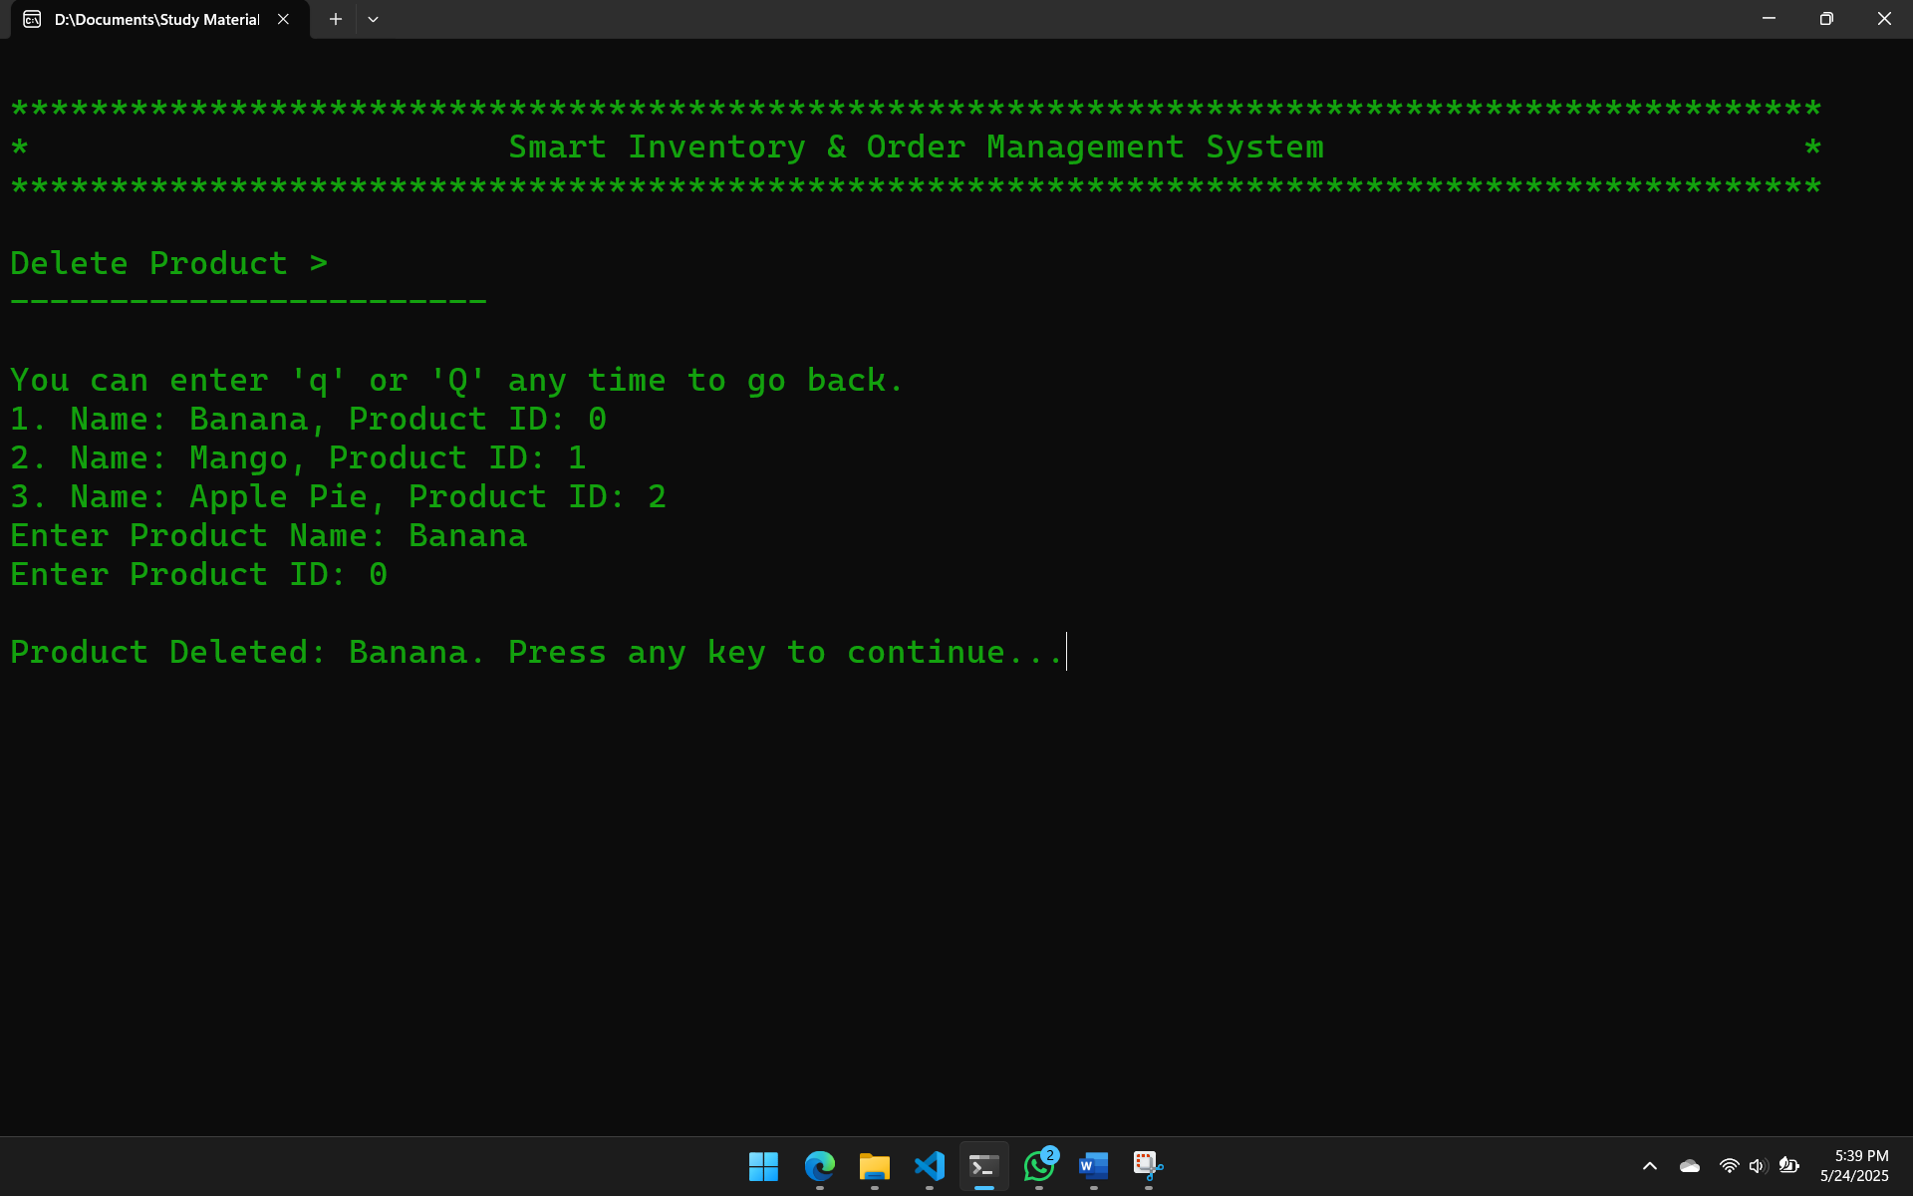

* **Admin Menu > Order History:**

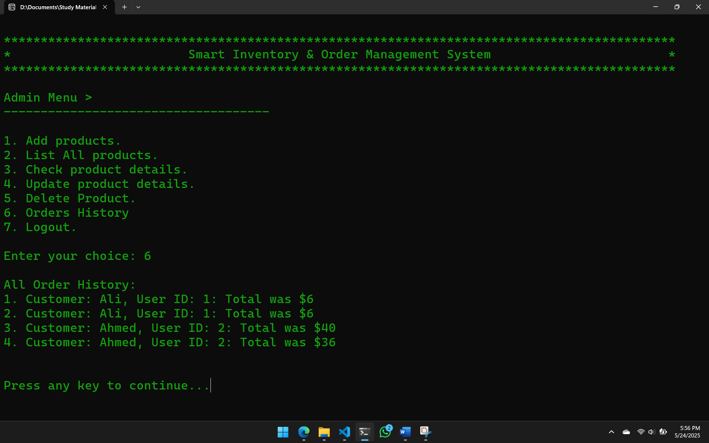

* **Customer Menu:**

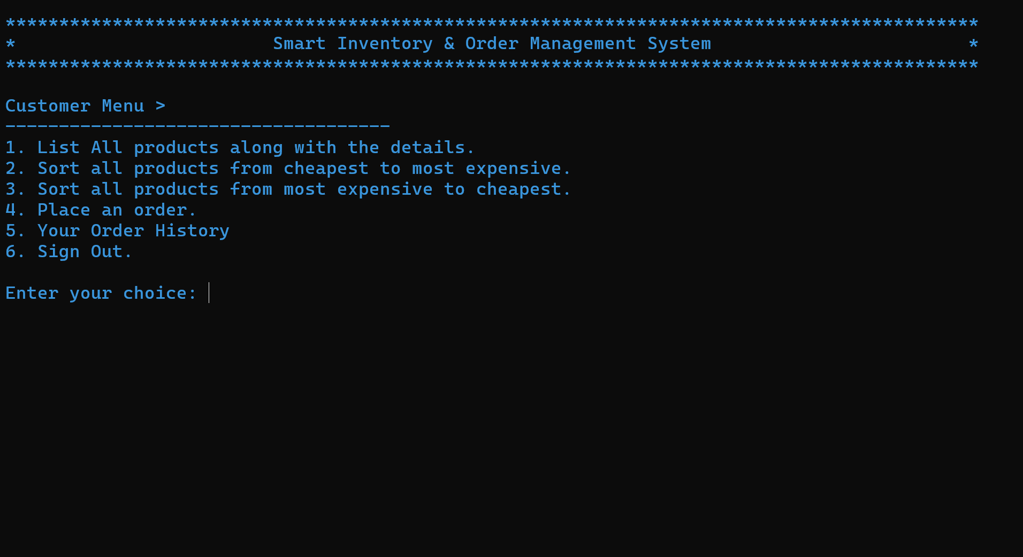

* **Customer Menu > List Products with Details:**

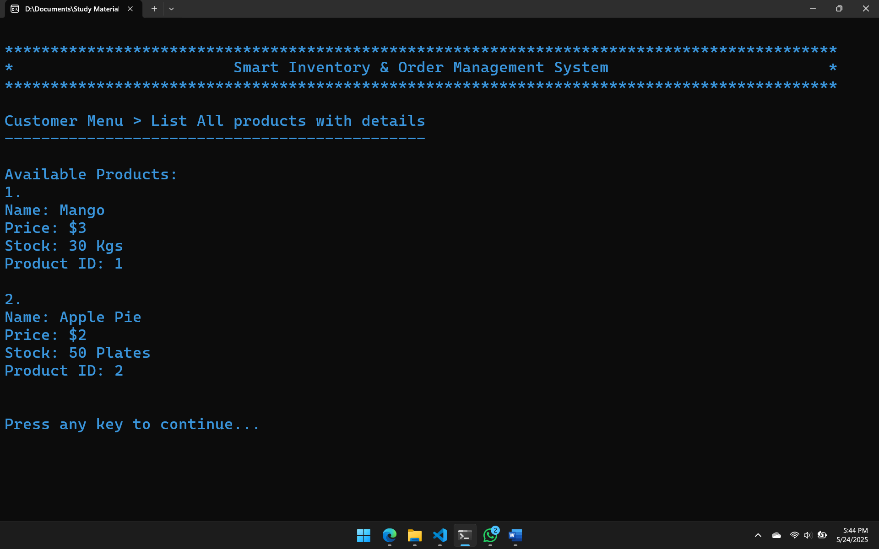

* **Customer Menu > Sorting:**

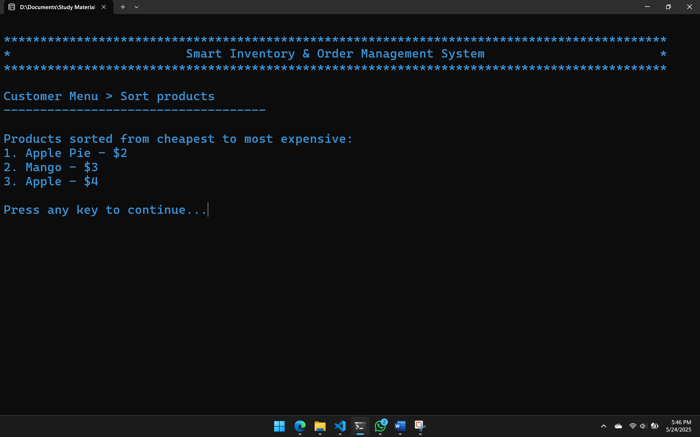

* **Customer Menu > Place Order:**

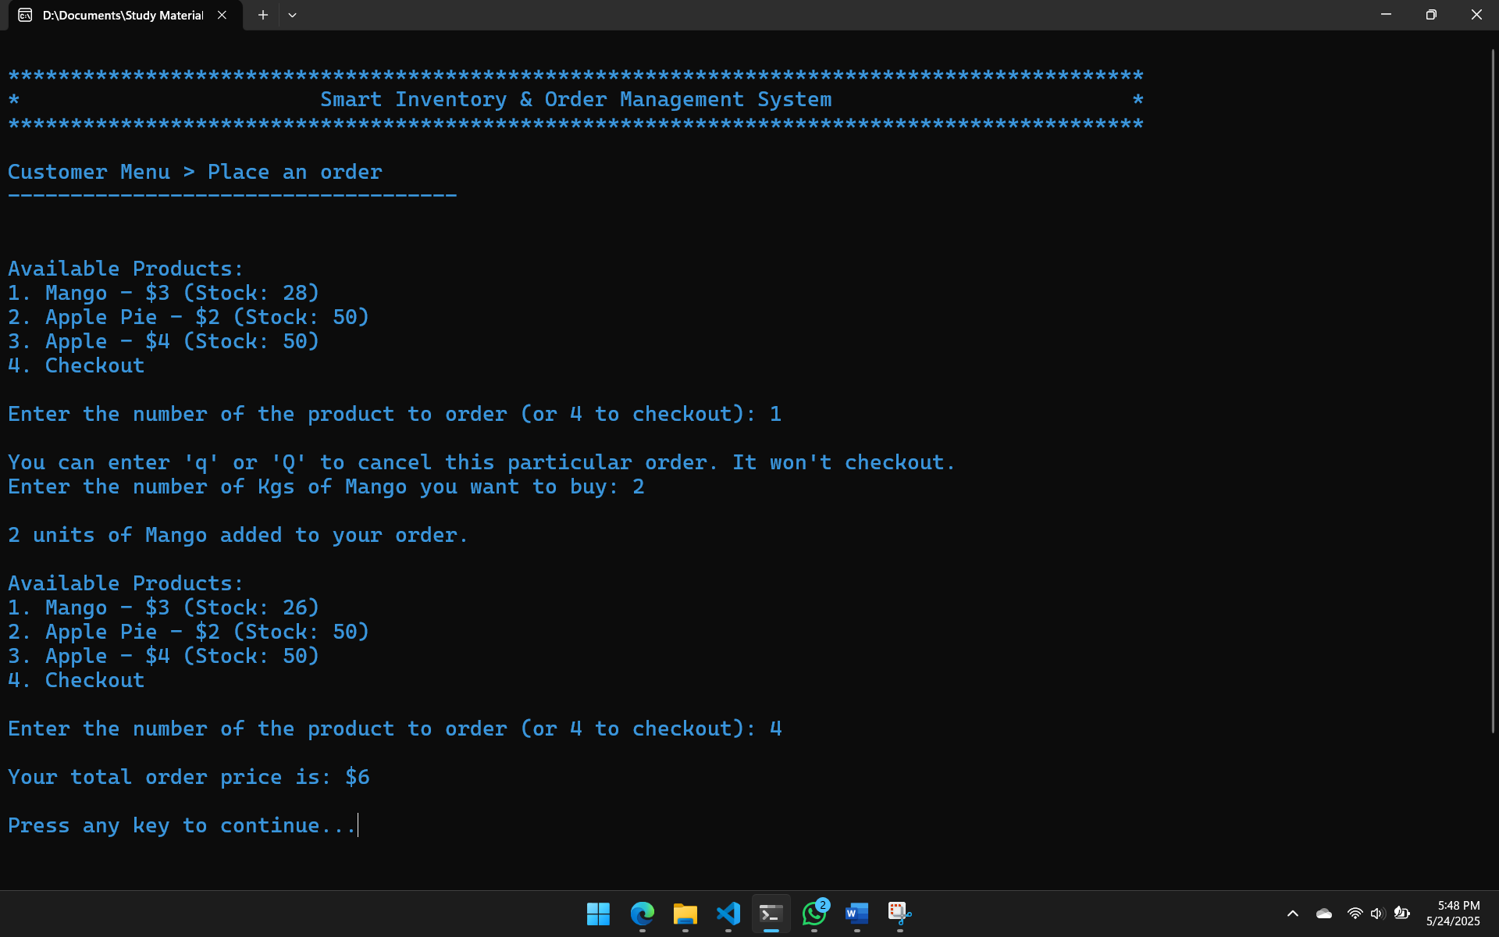

* **Customer Menu > Customer’s Orders History:**

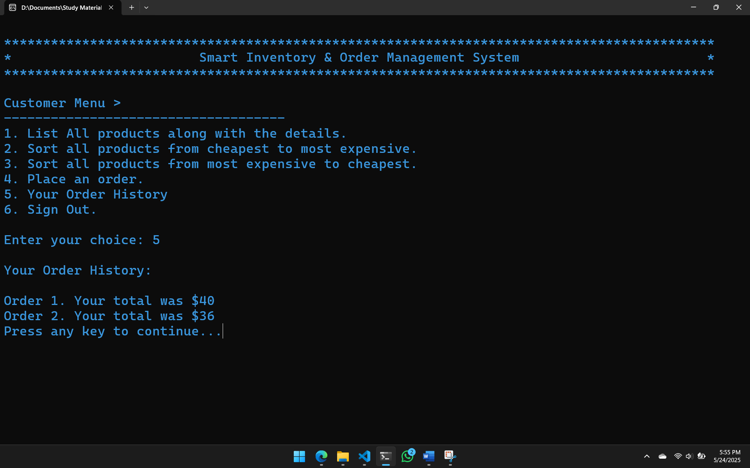

🗃️ **Data Structures**

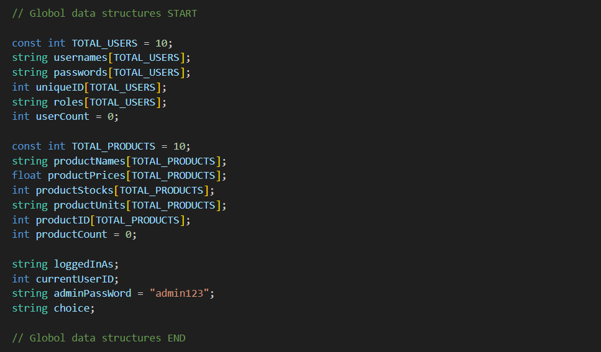

🛠️ **Function Prototypes**

